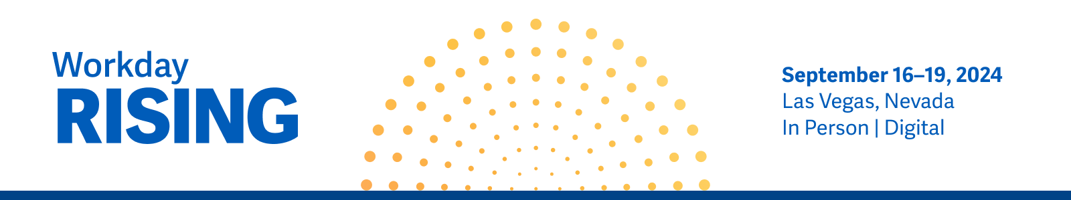

Workday Rising—Request to Attend

Hi, [Name],

I’m requesting your approval to attend Workday Rising, taking place September 16 - 19, 2024, at the Mandalay Bay Convention Center in Las Vegas, NV. Celebrating its 16th year, Workday Rising has established itself as the ultimate resource for how the future works and what’s currently happening in our industry, including innovations in AI and machine learning (ML).

Event overview.
Workday Rising is a customer-centric conference for existing and prospective Workday customers to learn how to use the Workday platform to achieve organizational goals. Facilitated by Workday product experts and partners, Workday Rising gives hundreds of finance, HR, and IT professionals the opportunity to connect, learn, and discover new ways to maximize their investment.

Benefits.
Attendees report the investment of time and money was justified by learnings that could immediately drive improved outcomes across the organization across four main impact areas.

Projects and initiatives.
Specifically, I’d like to focus on exploring solutions and process improvements for the following projects at our organization:
● [add project or initiative]
● [add project or initiative]
● [add project or initiative]

Cost.
Here’s a breakdown of my approximate conference costs based on flying to Las Vegas, including a special discount of $200 off the regular conference pass for Early Bird registration:

Item | Early Bird  May 29 - June 26 | Regular  Begins June 27
Registration Fee | $1,995 | $2,195
Average U.S. Airfare | $600 | $600
Ground Transportation | $100 | $100
Hotel (3 Nights at $210) | $630 | $630
Meals/Expenses for 4 days at $1005 (3 days of lunches and snacks, with two evening hosted receptions) | $400 | $400
TOTAL | $3,725 | $3,925

I’m confident that Workday Rising will benefit our organization, our team, and me. After the conference, I’ll summarize what I learned and share it with our teams.

Thank you in advance for considering this request.

[Signature]

P.S. Here’s what a couple Workday customers are saying about the conference:

“Set aside the time, dedicate the resources to attend [Workday Rising]. With Workday Rising, the networking to meet other Workday customers and the knowledge that you gain by doing this is just priceless. It’s about the networking and interacting with others, it’s about learning and education, it’s about networking with the Workday team themselves, so there’s just no price you can put on that.”—Senior Director Finance, Panera Bread

“Workday Rising is probably the MOST effective and value-added conference that we have been to. It’s because Workday Rising offers the ability to connect with other customers, to connect with your peers, to connect with Workday product folks, to learn about the vision, to learn about the strategy, to have deep-dive sessions, and to have Braindates and workshops. It’s all of those things that allow the value to be there.”—Director, HR Systems & Analytics, Wegmans Food Market, Inc.

